Day 20
Task 1:
Task 2:
Task 3: The below is violating SRP complete it and also … plz implement the SRP principle and rewrite the code.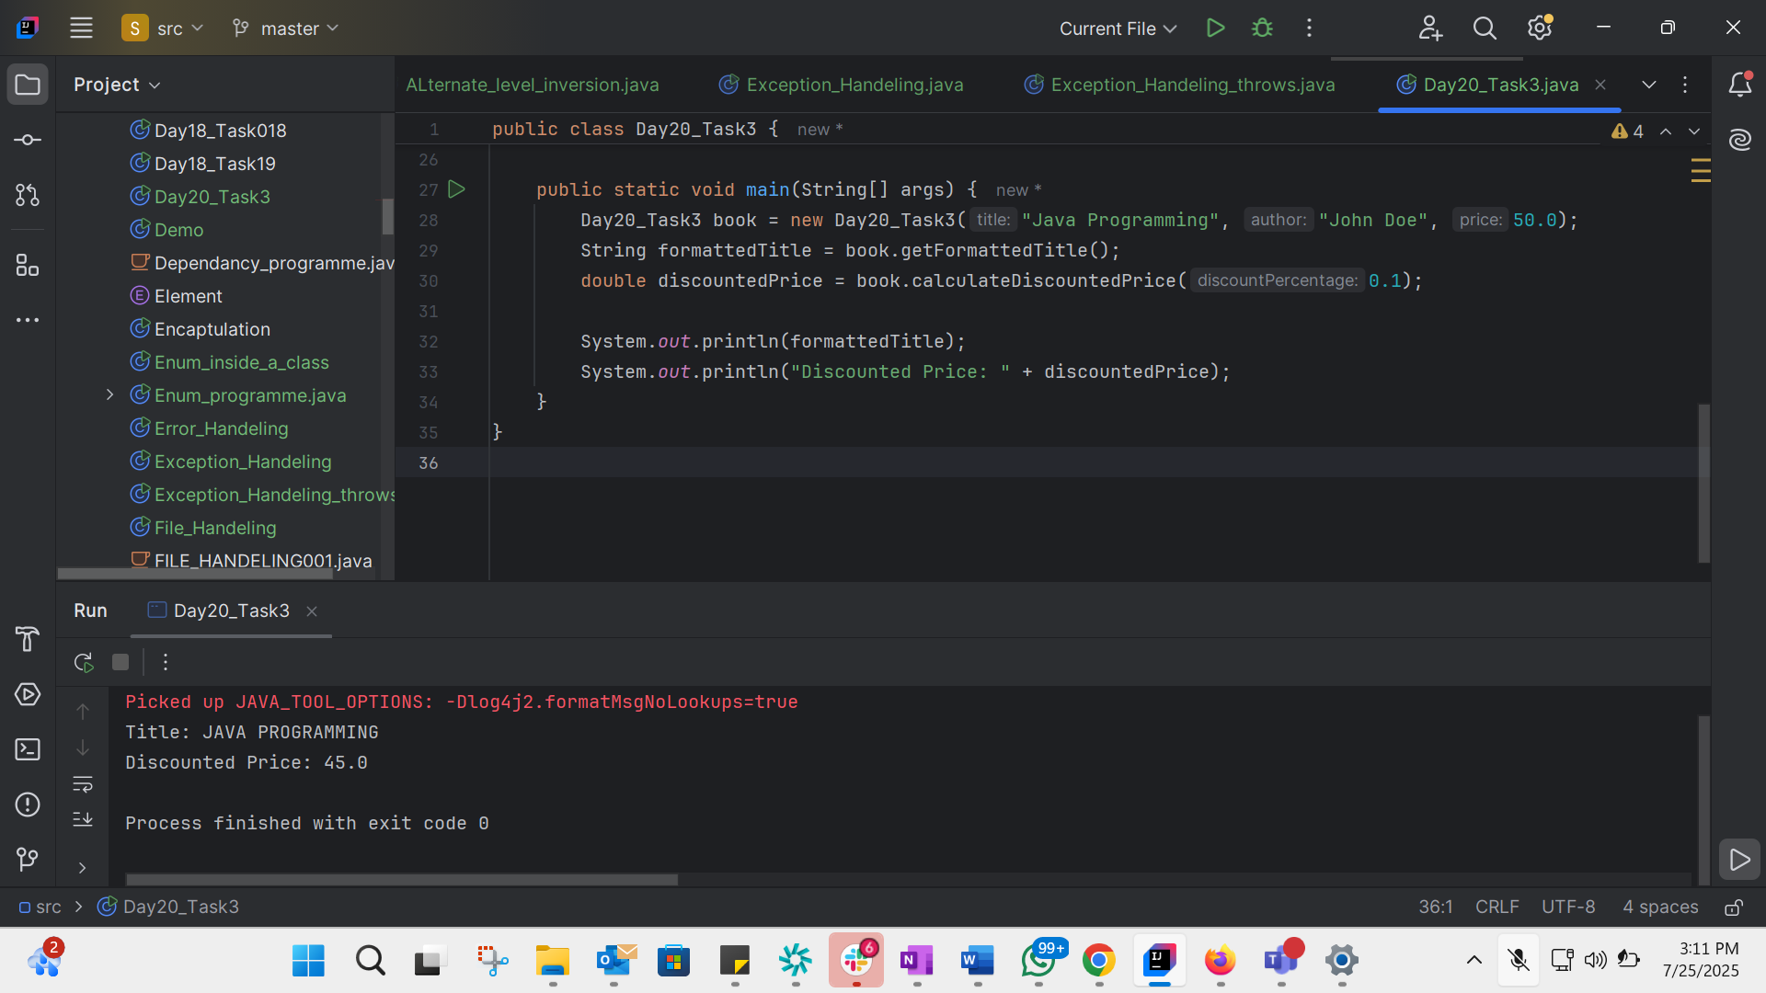
public class Day20_Task3 {
private String title;
private String author;
private double price;
public Day20_Task3(String title, String author, double price) {
this.title = title;
this.author = author;
this.price = price;
}
// Book details responsibility
public String getBookDetails() {
return "Title: " + title + ", Author: " + author + ", Price: " + price;
}
// Formatting responsibility
public String getFormattedTitle() {
return "Title: " + title.toUpperCase();
}
// Pricing responsibility
public double calculateDiscountedPrice(double discountPercentage) {
return price * (1 - discountPercentage);
}
public static void main(String[] args) {
Day20_Task3 book = new Day20_Task3("Java Programming", "John Doe", 50.0);
String formattedTitle = book.getFormattedTitle();
double discountedPrice = book.calculateDiscountedPrice(0.1);
System.out.println(formattedTitle);
System.out.println("Discounted Price: " + discountedPrice);
}
}

Task 5: Applying the open-closed principle in Java
interface Shape {
double area();
}
class Square implements Shape {
int height;
Square(int height) {
this.height = height;
}
public double area() {
return height * height;
}
}
class Circle implements Shape {
int r;
Circle(int r) {
this.r = r;
}
public double area() {
return Math.PI * r * r;
}
}
class ShapeComparator {
public double compareArea(Shape a, Shape b) {
return a.area() - b.area();
}
}

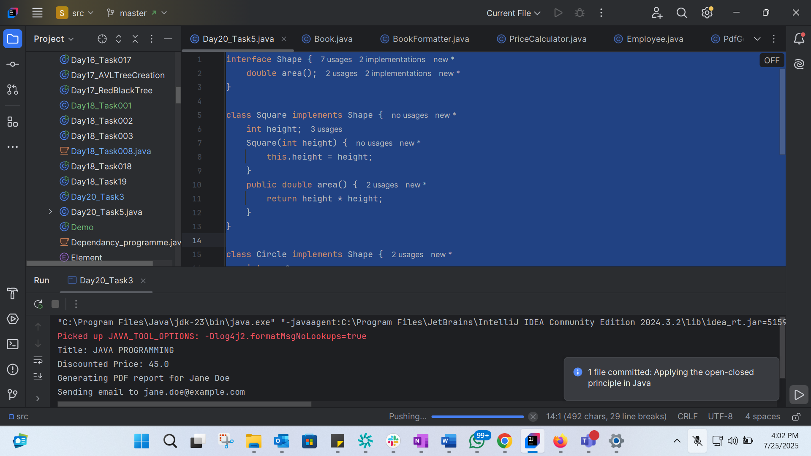
Task 6: Can you guys create diagrams for structural diagrams…
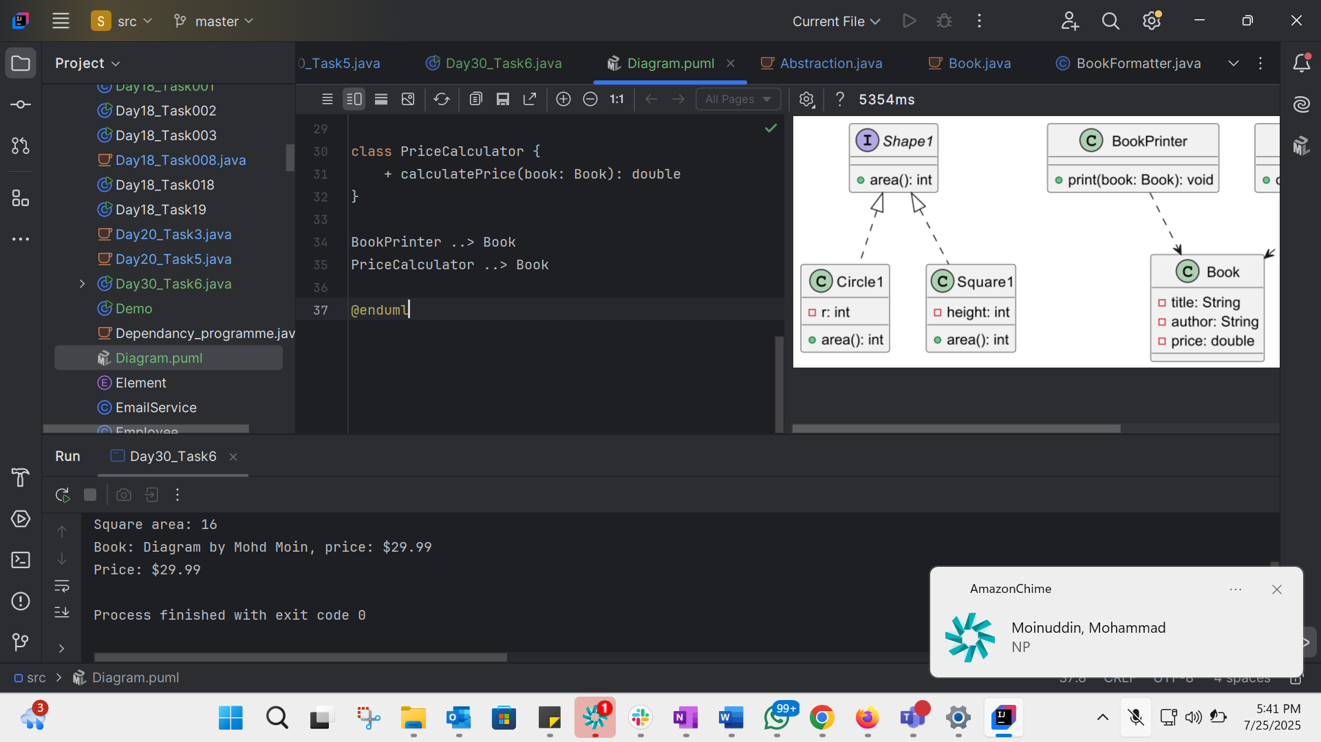
@startuml
interface Shape1 {
+ area(): int
}
class Circle1 {
- r: int
+ area(): int
}
class Square1 {
- height: int
+ area(): int
}
Shape1 <|.. Circle1
Shape1 <|.. Square1
class Book {
- title: String
- author: String
- price: double
}
class BookPrinter {
+ print(book: Book): void
}
class PriceCalculator {
+ calculatePrice(book: Book): double
}
BookPrinter ..> Book
PriceCalculator ..> Book
@enduml
import java.lang.Math;
interface Shape1 {
int area();
}
class Circle1 implements Shape1 {
int r;
Circle1(int radius) {
this.r = radius;
}
public int area() {
return (int) (Math.PI * r * r);
}
}
class Square1 implements Shape1 {
int height;
Square1(int height) {
this.height = height;
}
public int area() {
return height * height;
}
}
class Book {
String title;
String author;
double price;
Book(String title, String author, double price) {
this.title = title;
this.author = author;
this.price = price;
}
}
class BookPrinter {
void print(Book book) {
System.out.println("Book: " + book.title + " by " + book.author + ", price: $" + book.price);
}
}
class PriceCalculator {
double calculatePrice(Book book) {
return book.price;
}
}
public class Day30_Task6 {
public static void main(String[] args) {
// Use Circle1 and Square1 here
Shape1 c = new Circle1(5);
Shape1 s = new Square1(4);
System.out.println("Circle area: " + c.area());
System.out.println("Square area: " + s.area());
Book book = new Book("Diagram", "Mohd Moin", 29.99);
BookPrinter printer = new BookPrinter();
PriceCalculator calculator = new PriceCalculator();
printer.print(book);
System.out.println("Price: $" + calculator.calculatePrice(book));
}
}

